Functional gene Amplicon Sequencing test (FASt): A rapid metagenomic-enabled method for development of multiple biomarkers of TOrC biodegradation
Janiszewski, Lara N. ¹; Sachdeva, Neha ¹; Schmaljohn, Ellen ⁵; Chaparro, Jacqueline M ²; Diaz, Gustavo³; Topp, Justin⁵; Downey, Nick⁵; Broeckling, Corey D.³; Koslovsky, Matthew D.⁴, Prenni, Jessica E.²; De Long, Susan K. ¹

¹Department of Civil and Environmental Engineering, Colorado State University, Fort Collins, CO
²Department of Horticulture and Landscape Architecture, Colorado State University, Fort Collins, CO
³Analytical Resources Core – Bioanalysis and Omics Center, Colorado State University, Fort Collins, CO
⁴Department of Statistics, Colorado State University, Colorado State University, Fort Collins, CO
⁵Integrated DNA Technologies, Coralville, IA

ABSTRACT
Biological treatment offers a promising path for removing trace organic contaminants (TOrCs) from wastewater and impacted surface waters, but progress has been limited by the absence of functional biomarkers capable of identifying contaminant-degrading microorganisms in complex microbiomes. We introduce the Functional gene Amplicon Sequencing test (FASt), a multiplexed functional gene–targeted amplicon sequencing platform designed to detect rare but catalytically important xenobiotic-degrading genes in complex microbial communities. To enable biomarker discovery, we generated 415 custom rhAmpSeq assays targeting cytochrome P450 monooxygenases identified from metagenomes of wastewater-derived microbial consortia. Activated sludge and effluent-impacted sediment communities were acclimated to a mixture of 12 TOrCs and subsequently evaluated in batch degradation assays with and without the cytochrome P450 inhibitor 1-aminobenzotriazole. Results demonstrated P450-associated degradation of ibuprofen, atenolol, estradiol, gabapentin, and acetaminophen, providing the first evidence of P450-dependent ibuprofen degradation by bacterial consortia. FASt identified 12 P450 genes whose temporal dynamics were significantly correlated with these degradation patterns, revealing compound-specific P450 “fingerprints.” Five P450 genes correlated with ibuprofen loss, assigned to Sphingomonas, Pseudomonas, and members of the Hyphomicrobiales. P450s associated with atenolol and estradiol degradation were assigned to Sphingorhabdus and Sphingomonas, taxa present at low metagenomic abundance but known for xenobiotic metabolism. While further biomarker validation is required, results establish FASt as a new tool for functional gene biomarker discovery in environmental microbiomes.

- Introduction
Our water system, including wastewater, stormwater, and surface water, is broadly polluted with dozens to hundreds of different trace organic contaminants (TOrCs), including pharmaceuticals, personal care products, antimicrobial chemicals, chlorinated flame retardants, pesticides, and herbicides. Toxicological studies suggest chronic exposure to low levels (ng/L) of TOrCs, particularly as mixtures, may lead to health impacts including cancer and could negatively affect human fetal development^{1–6}. One promising approach for tackling TOrC pollution is through biological treatment technologies, applied at municipal wastewater reclamation facilities as well as to stormwater and agricultural runoff.
While a substantial body of research has focused on developing biological TOrC treatment, technologies that lead to robust, predictable contaminant removal have yet to be demonstrated. Successful treatment relies on maintaining the presence and activity of critical TOrC-degrading microorganisms within treatment reactor microbiomes (25, 26 from proposal). However, to date researchers have been forced to take a “black box” approach to developing TOrC biotreatment technologies, as no molecular assays exist to directly probe reactor microbiomes for TOrC-biodegrading microbes and their activity (i.e., using genetic biomarkers). Thus, there is a critical need to develop tools for monitoring TOrC-degrading genetic potential and activity to support rapid advancements in biological treatment technologies.
Conventional biomarker development approaches only address one contaminant at a time, typically relying on pure cultures grown with high contaminant concentrations. Addressing TOrC contamination requires a different approach because there are dozens of important TOrCs, relevant concentrations are extremely low, and pure laboratory cultures often do not represent the microbes that dominate in full-scale treatment reactors⁷. Rapidly developing field-relevant biomarkers for TOrC contamination should target mixed microbiomes and ideally probe genes relevant to biodegradation of multiple contaminants simultaneously.
Further, assessment of degradation potential requires functional assays which are gene centered instead of taxa centered. To this end, we have focused this work on cytochrome P450 genes, which code for heme-containing, multicomponent enzymes. P450s are structurally conserved, but functionally diverse, monooxygenases and are ubiquitous in living systems. These enzymes are instrumental in bacterial metabolism, and certain P450 subclasses (e.g., CYP1A, CYP2A, CYP2B, CYP2C, CYP2D, CYP2E, and CYP3A) are specifically involved in the degradation of xenobiotic compounds. Importantly, over 18,000 distinct bacterial and archaeal P450 enzymes are known, and we identified hundreds of potentially relevant P450 and xenobiotic degradation enzyme-encoding genes in the metagenomes of the TOrC-degrading cultures used in this research (Supplemental). Thus, a set of quantitative PCR assays could not simply be designed to quantify, and screen, all of these genes.
To address this challenge, herein we report critical advances toward developing a suite of functional gene-based biomarkers for aerobic TOrC biodegradation using a novel Functional gene Amplicon Sequencing tests (FASt) approach. FASt biomarker development is based on high specificity rhAmp PCR assays (Dobosy*****), which incorporate RNase H2-dependent elongation. This technology allows hundreds of targets to be amplified in multiplex; amplicons are subsequently sequenced for identification. Although the utility of rhAmp PCR has been demonstrated for single nucleotide polymorphism and CRISPR applications (Shapiro*****),t has yet to be used widely for functional amplicon sequencing. Here, we demonstrate a novel use of rhAmp PCR by applying it to functional biomarker development to screen hypothesized biomarker genes. A suite of functional gene assays for TOrC biodegradation is expected to have widespread fundamental implications regarding how TOrC biotreatment technologies are developed, optimized, and monitored. While this work focuses on aerobic TOrC biodegradation, the FASt biomarker development approach is readily extendable to a broader range of contaminants, reactor conditions, or tangential fields.
- Materials and Methods
  - Inoculum sources and acclimation
Cultures were collected at the Drake Water Reclamation Facility (Fort Collins, Colorado, United States). Aerobic activated sludge (AS) was obtained from a Drake reactor and sediment (SD) was obtained from the Fossil Creek Ditch, which receives facility effluent. Semi-continuous batch biofilm reactors were assembled for TOrC acclimation as described previously^{8,9}. Briefly, 120 g of laboratory grade sand was added to 800 mL trace mineral solution (Milli-Q water with 8.5 mg/L KH₂PO₄, 21.75 mg/L K₂HPO₄, 33.4 mg/L Na₂HPO₄, 0.25 mg/L FeCl₃, 2.7 mg/L NH₄Cl, 22.5 mg/L MgSO₄, and 27.5 mg/L CaCl₂)¹⁰. Trace mineral solution and sand were autoclaved prior to the addition of 1 mL inoculum, 100 µg/L filter sterilized sodium acetate as a primary carbon source, and 12 TOrCs at 50 µg/L each: 5-fluorouracil, acetaminophen, estradiol, ibuprofen, triclosan, naproxen, diclofenac, atenolol, gabapentin, simvastatin, gemfibrozil, and phenytoin. Reactor flasks were plugged with foam to allow gas exchange and run for 8 weeks at 25 °C and 100 rpm. Each week after biomass samples were taken, half of the media was replaced. This included nutrient solution, TOrCs, and sodium acetate.

  - Batch biodegradation
After acclimation, cultures were used to inoculate 8 100-mL bath biofilm reactors: killed controls in duplicate (autoclaved), live reactors in triplicate, and live reactors with a P450 inhibitor (1.5 mM 1-aminobenzotriazol¹¹) in triplicate. Briefly 50 g laboratory grade sand was added to 100 mL trace mineral solution and autoclaved. Then 1.5 mL of inoculum, 100 µg/L filter sterilized sodium acetate as a primary carbon source, and 12 TOrCs at 50 µg/L each were added as for the acclimation reactors. Reactors were run for 30 days at 25 °C and 100 rpm. Five biomass aliquots (2 mL each) were collected on days 0, 3, 5, 10, 15, 20, 25, and 30 post-inoculations. These were pelleted, decanted, and frozen at –80 °C. Additionally, 5 mL of pellet supernatant was retained for mass spectrometry and frozen at –80 °C.
  - Analytical methods
    - TOrC degradation analysis
200 µL of supernatant were diluted with 50 µL of LC-MS grade methanol spiked with 62.5 ng/mL of internal standard (ibuprofen-d3, gemfibrozil-d6, diclofenac-d4, and triclosan-d3). Additionally, equal volume of each sample was combined to generate a pooled quality control (QC) sample. Samples were stored in –80 °C until analysis. TOrC biodegradation analysis was conducted via Ultra-Performance Liquid Chromatography coupled with Tandem Mass Spectrometry (UPLC-MS/MS).Ten microliters of sample was injected onto an LX50 UHPLC system equipped with an LX-50 solvent delivery pump (20-µL sample loop, partial loop injection mode; PerkinElmer, Shelton, CT, USA). An ACQUITY UPLC HSS T3 column (1 x 100 mm, 1.8 µM; Waters Corporation, Milford, MA, USA) was used for chromatographic separation. The column was maintained at 60 °C, Mobile phase A consisted of 0.1% formic acid in LC-MS grade water, and mobile phase B was 0.1% formic acid in LC-MS grade acetonitrile. The elution gradient was initially at 1% B for 1 min, which was increased to 76% B at 12 min, further increased to 97% B at 12.1 min, then decreased to 1% B at 12.2 mins. The column was re-equilibrated for 3.2 mins for a total run time of 10 min. The flow rate was set to 250 µL/min. Detection was performed on a PerkinElmer QSight 220 triple quadrupole mass spectrometer (MS) equipped with an electrospray ionization source and operated in selected reaction monitoring (SRM) mode with polarity switching between positive and negative ionization. SRM transitions for each compound were optimized through analysis of authentic standards (Supplementary Table S1). The MS operated with a drying gas 120 (arbitrary units), a hot-surface induced desolvation (HSID) temperature of 320 °C, electrospray voltage at 5000 eV (positive mode) or -4500 eV (negative mode), a nebulizer gas flow of 350 (arbitrary units), and a source temperature at 300 °C. The MS acquisition was scheduled by retention time with 1.0 min windows. Samples were injected in randomized order with a pooled QC being injected after every 6 injections.
Data processing was performed using Simplicity 3Q™ software (Version 1.9, PerkinElmer). Peak retention times corresponding to SRM transitions for each compound were validated against authentic standards. Each target analyte was visually inspected for retention time and peak area integration. Peak areas were extracted for target compounds detected in samples and normalized to the peak area of the appropriate internal standard or surrogate in each sample. Absolute quantitation, defined as ng of compound in mL of extract (ng/mL), was calculated using a linear regression model fit for each compound from the calibration curve.
`
    - Metabolomic analysis
An extensive search for known and putative degradation products of the TOrCs was undertaken using nontargeted LC-MS/MS analysis. The samples from days 0, 7, and 25 were analyzed for both the AS and SD bioreactors. One microliter of extract was injected onto a Waters Acquity UPLC system (Waters Corporation, Milford, MA). Separation was achieved using a Waters ACQUITY UPLC HSS T3 column (Waters Corporation, Milford, MA; 1.7μM, 2.1 × 100 mm), using a gradient from solvent A (LC-MS water, 0.1% formic acid) to solvent B (LC-MS acetonitrile, 0.1% formic acid). Injections were made in 99% A, held at 99% A for 1 min, ramped to 98% B over 13 min, held at 98% B for 3 min, and then returned to starting conditions over 0.05 min and allowed to re-equilibrate for 3.95 min, with a 500μL/min constant flow rate. The column and samples were held at 45 and 6 °C, respectively. The column eluent was infused into a Waters G2-XS Q-TOF-MS with an electrospray source in positive mode, scanning 50−1200 m/z at 0.1 s per scan, switching to MS/MS after individual ion intensity rises above 50000. MS/MS acquisition occurred at a scan rate of 0.5 s, or after accumulated total ion current (TIC) threshold of 100,000, with 5 MS/MS events per MS1 scan. Collision energy for MS/MS was ramped from 15 to 30 V. Calibration was performed using sodium formate, ensuring a 1 ppm mass accuracy. The capillary voltage was held at 700 V in positive mode. The source temperature was held at 150 °C and the nitrogen desolvation temperature at 450 °C with a desolvation flow rate of 1000 L/hr. The Lockspray reference mass (LeuEnk, 556.2771 m/z) was used to correct for m/z drift, with 40 seconds interval between scans, 0.1 seconds/scan and signal averaged over 3 scans.
Lockspray signal was collected during analysis, but correction was not applied until post-processing. Post-processing for mass correction and compatibility used Waters Tynebridge to produce mzML files. Each sample was injected ten times using Waters FastDDA mode, with post-processing conducted after each injection to generate iterative exclusion lists using AutoCat_V1 processing. The exclusion list was reset (deleted) between distinct samples.
For LC-MS/MS data-dependent acquisition (DDA) data, .mzMLfiles were first processed in MS-DIAL¹² using the conventional DDA MS/MS method. The data collection type was set to centroided with the following parameters: MS1 tolerance 0.01 Da, MS2 tolerance 0.025 Da, MS1 mass range begin: 50 Da, MS1 mass range end: 1200 Da, MS2 mass range begin: 50 Da, and MS2 mass range end: 1200 Da. Peak detection parameters were as follows: a minimum peak height of 1000, a mass slice width of 0.1 Da, and smoothing was set to a linear weighted moving average with a smoothing scan of 3 and a minimum peak width of 5. Identification was conducted using MassBank of North America (MoNA) public libraries with default MS-DIAL parameters. Adducts chosen were [M + H]⁺, [M + NH₄]⁺, [M + Na]⁺, and [M + K]⁺. [M + H −H₂O]⁺. MS2Dec was set to default parameters. Alignment parameters used a retention time of 0.05 min and an MS1 tolerance of 0.015 Da. “Suggested (w/o MS2) metabolite features” were excluded. Raw peak area data matrix and the GNPS export feature were then used to generate the MS/MS spectral summary file containing the list of representative MS/MS spectra (the most intense MS/MS spectrum) and the feature quantification table containing compound intensity and annotation.
      - Molecular Networking and Spectral Library Search.
A molecular network was created with the Feature Based Molecular Networking (FBMN)² workflow on GNPS2 (https://gnps2.org). The MS/MS spectral summary file and the quantification results file generated from MS-DIAL were imported to GNPS for FBMN analysis. The precursor ion tolerance was set to 2, and the fragment ion tolerance was set to 0.5. The minimum peak intensity was set to 0.0. A molecular network was then created where edges were filtered to have a cosine score above 0.6 and more than 2 matched peaks. The spectra in the network were then searched against public GNPS spectral libraries. The library spectra were filtered in the same manner as the input data. All matches kept between network spectra and library spectra were required to have a score above 0.6 and at least 2 matched peaks.
    - Proteomics
Protein was extracted by resuspending bioreactor sample pellets in Alkalyne-SDS buffer ((5% SDS, 50 mM Tris-HCl, pH 8.5; 0.15 M NaCl; 0.1 mM EDTA; 1 mM MgCl2; 50 mM Dithiothreitol (DTT)) with 1X HALT Protease Inhibitor (Thermo Scientific). Samples were then transferred to 2mL reinforced polypropylene bead beating tubes (Fisher) containing stainless steel and 0.1mm zirconia silica beads. Samples were beaten at 6m/s for 5 cycles of 45 seconds, with 2min dwell time on ice between cycles. Following cellular lysis, samples were centrifuged at 8,000 x G for 10 minutes, and the supernatant was transferred to new 2mL tubes. 1.6mL of -20°C acetone was added to 400 uL of each sample, then incubated overnight at -20°C. Then, samples were centrifuged at 16,000 x G for 20 minutes at 4°C to pellet proteins. Protein pellets were washed (3x) with 300uL chilled (-20°C acetone) and centrifuged at 16,000 x G for 10 mins at 4°C. Total protein content was measured using the Pierce BCA Protein Assay Kit (ThermoFisher Scientific) following manufacturer instructions. Absorbance at 550nm was measured on a BioRad 680 microplate reader and total protein concentrations calculated based on a bovine serum albumin standard curve fit to a quadratic (Microplate Manager 5 software, BioRad). Protein samples were digested using the EasyPep Mini MS Sample Prep Kit (ThermoFisher Scientific) following the manufacturer’s instructions. Briefly, 100µg total protein was aliquoted from each sample and raised to 100µL with lysis buffer. Reduction and alkylation solutions were sequentially added followed by incubation at 95˚C for 10 minutes. After cooling to room temperature, 50 µL of a 0.2 µg/µL Trypsin/LysC mixture was added, and samples were digested with shaking at 37ºC for 2 hours. The enzymes were then deactivated with the Digestion Stop Solution and contaminants removed using mixed mode peptide clean up columns. Peptide eluate was dried in a vacuum evaporator and resuspended in 3% acetonitrile/0.1% formic acid.
Reverse phase chromatography was performed using water with 0.1% formic acid (A) and 80% acetonitrile with 0.1% formic acid (B). A total of 0.8 μg of peptides was purified and concentrated using an on-line enrichment column (Thermo Scientific PepMap Neo C18 5µm, 300 µm ID x 0.5cm). Subsequent chromatographic separation was performed on a Vanquish Neo (Thermo Scientific) on a reverse phase nanospray column with integrated silica emitter (ionopticks Aurora Ultimate Gen 3 C18 1.7µm, 75 µm ID x 25cm column, 45°C) using a 90 minute gradient at a flow rate of 300 nanoliters/min: 1-6%B over 3 minutes followed by 6-35%B over 70 minutes, 35-45%B over 5 minutes ending in 12 minutes of washing at 500 nanoliters/minute, 99%B. Peptides were eluted directly into the mass spectrometer (Orbitrap Eclipse, Thermo Scientific) equipped with a Nanospray Flex ion source (Thermo Scientific) and spectra were collected over a m/z range of 375–2000 under positive mode ionization. Ions with charge state +2 or higher were accepted for MS/MS using a dynamic exclusion limit of 1 MS/MS spectra of a given m/z value with an exclusion duration of 60 s. The instrument was operated in FT mode for MS detection (profile; resolution of 240,000) and ion trap mode for MS/MS detection with a normalized HCD collision energy set to 30% and data centroided.
Proteome Discoverer (PD) 3.0 was used for data processing (Thermo Scientific). A precursor detector node with S/N=1.5 was used to identify additional precursors within the isolation window of the precursor spectrum when chimeric or mixed spectra was present. Spectra from all samples were searched using the Sequest HT [3] node, setting methionine oxidation as dynamic and cysteine Carbamidomethylation as fixed modifications. Subsequently, the data was submitted to an intensity-based rescoring process (INFERYS node in PD) using a deep learning method to predict fragment ion intensities [4]. Raw data were interrogated against customized amino acid FASTA A data set which merged: a. UniprotKB filter using: "cytochrome P450" AND (taxonomy_id:2)” with 217,832 protein entries. b. A subset of data from the Universal bacteria collection of reference proteomes from Uniprot selecting only entries with the key word “Cytochrome P450”, 33,989 protein entries. c. Two metagenomic derived FASTAs from the AS and SD metagenomes; after merging and removing duplicates the final data set contained 630,798 sequences out of which 110,881 were bacterial P450; (3) Additionally, the cRAP proteome was interrogated. (The common Repository of Adventitious Proteins -cRAP- contains commonly found contaminant proteins in proteomics experiments.) Sequest HT was searched with a fragment ion mass tolerance of 0.60 Da and a parent ion tolerance of 10 PPM. Peptide spectral matches (PSMs) were validated using the Percolator node [5]. Thresholds were set such that a false discovery rate of ≤1% and protein identification was defined with at least one peptide.
  - FASt assay development
Metagenomic shotgun sequencing was performed on biomass samples from acclimation week 6 containing the highest DNA concentrations (Figure S1). Metagenomes were assembled and annotated using Metagenomic Rapid Annotations using Subsystems Technology (MG-RAST)^{15–17}. Sequences were classified with the ‘best hit’ method and filtered to only include those labeled as “monooxygenase”, “dioxygenase”, or “P450”. These were filtered for quality as well, with final gene targets having a minimum e-value of 1, minimum percent identity of 95%, minimum abundance of 1, and minimum alignment length of 100 nucleotides. Ultimately targets were narrowed to P450 genes. These targets were used by IDT to create novel RhAmpSeq primer sets. In total, 415 primer pairs (assays) were pooled into 2 multiplexed master mixes with 280 and 35 assays respectively.
Library amplification was first attempted with the SNP protocol, which indicated 10 rounds of amplification with targeted primers. However, this produced amplicons smaller than the designed range (figure 1). [I have gel data showing this, do we want it?] Both 20 and 30 cycles of PCR were tested, and both resulted in amplicons in the desired range. However, 30 cycles produced additional off target amplification, so libraries amplified for 20 cycles were subsequently sequenced.
Figure 1: Histogram of amplicon sequence sizes (IDT)
  - FASt analysis of biodegradation bioreactors
DNA was extracted using ZymoBIOMICS Quick-DNA/RNA Miniprep kits and processed using IDT’s RhAmpSeq library preparation protocol (document ID NGS-10122-PR 03/2019). Extracted DNA concentrations were all less than 10 ng/µL, so none were diluted prior to amplification. Per the protocol, 11µL of DNA was added to each reaction, resulting in an average of 55 ng DNA per reaction. PCR cleanup steps used Agencourt Ampure XP Beads. Unique dual i5/i7 indices (IDT) were added to each sample, and samples were pooled such that all assays were at the same concentration. Samples were sequenced at the CSU Veterinary Diagnostic Laboratory using a MiSeq v2 300 flow cell. The cell was used as 2x150 for paired end reads.
Within a Qiime2/2024.2_amplicon¹⁹ environment, data were denoised, filtered, and truncated using Dada2¹⁸. Taxa designations wereRedundancy analysis (RDA) was used to model the effect of our explanatory matrix, unweighted unifrac distances, on our response matrix, and drug degradation data. This is the reverse of a typical ecological RDA which uses environmental data as the explanatory matrix and primary component analysis data as the response matrix. Because we cannot have more explanatory variables than response variables, ASV abundance (total counts) and prevalence (number of samples it appears in) were used to choose the 25 top ASVs as explanatory variables. These taxa counts were Hellinger transformed to help linearize distances between samples and to reduce the impact of dominant species. The final RDA model additionally included time as a main effect and reactor ID as a random effect to account for repeated measures. See the provided R code for more details.
- Results
  - TOrC biodegradation capacity of wastewater inocula
Of the 12 TOrCs investigated, data suggested that 5 of these were biodegraded via pathways involving P450 enzymes. Ibuprofen (Ibu), a non-steroidal anti-inflammatory drug (NSAID), was the only TOrC in this study degraded to undetectable levels in both uninhibited cultures while undergoing no detectable degradation in either P450-inhibited culture (Figure 1a). These data indicate that Ibuprofen degradation was P450-mediated for both inoculum sources used in this study.
Degradation of atenolol (a beta blocker) showed distinct kinetics for AS and SD microbiomes (Figure 1b). 50% of the compound remained after 30 days in uninhibited SD reactors, while no discernible degradation occurred in inhibited SD reactors until after 25 days. In fact, the apparent drop in atenolol levels between day 25 and day 30 was consistent across all SD reactors including killed controls, possibly indicating a systemic error instead of true degradation. In either case, P450 inhibition of the SD microbiome blocked most (if not all) atenolol degradation (SD vs SD-I p < 0.01). In contrast, atenolol was degraded in all experimental AS reactors, with inhibited reactors showing a small but significant delay compared to uninhibited (AS vs AS-I p < 0.03).
17-beta estradiol (E2) was fully degraded in uninhibited AS and SD cultures even more rapidly than Ibu, with the notable difference that P450 inhibition caused only a delay in E2 degradation (Figure 1c). These delays were statistically significant (SD vs SD-I p < 0.04, AS vs AS-I p < 0.01), and amounted to a 3–5-day delay in AS cultures and an approximately 2-day delay in SD cultures. Delays, without complete inhibition, caused by the P450 inhibitor suggest that either a non-P450 based pathway emerged or that the inhibitor concentration declined over time; 1-ABT irreversibly binds P450s resulting in consumption of the inhibitor over time and degradation in culture media over time has also been observed.
Gabapentin, an anticonvulsant, degraded only in the AS reactors (Figure 1d), and its degradation was delayed by P450 inhibition (AS vs AS-I p < 0.016). This delay appeared to widen as the gabapentin concentration decreased. In the SD reactor system e there was some variation in gabapentin degradation between the inhibited and uninhibited reactors. However, this result is difficult to interpret as we also observed gabapentin concentrations higher than baseline in inhibited cultures.
Acetaminophen was degraded by both cultures (Figure 1e), but P450 inhibition only delayed its degradation in the SD reactors (SD vs SD-I p < 0.02). These results suggest different acetaminophen biodegradation pathways were used in the two cultures. Triclosan and 5-fluorouracil were degraded in both cultures regardless of P450 inhibition, while the results for phenytoin, naproxen, diclofenac, and gemfibrozil were inconclusive. Only one of three AS reactors (R1) showed degradation of these four compounds, and none of the four were entirely degraded (Supplementary figure).
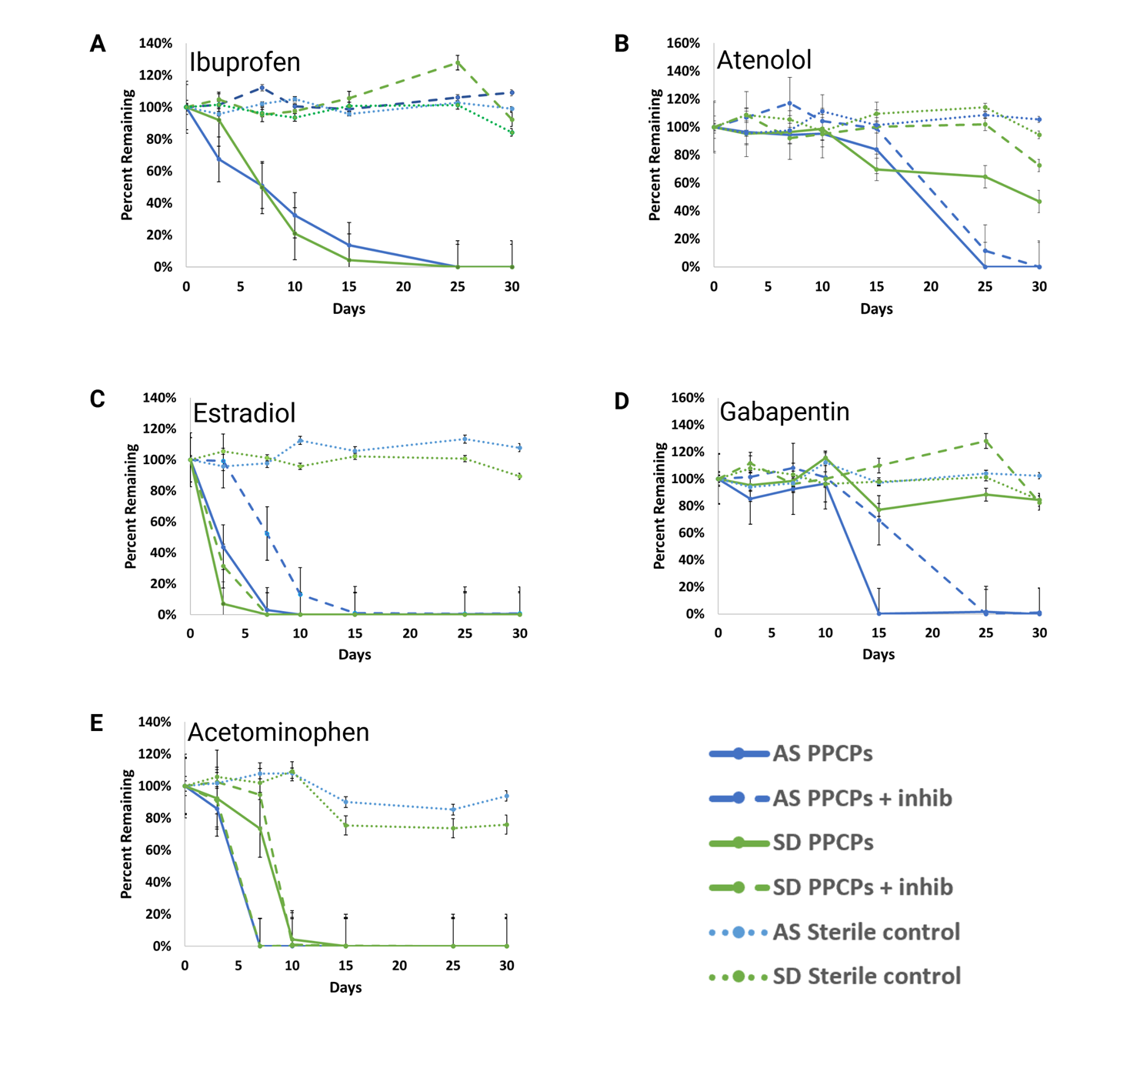
Figure 1. Time series data of LC-MS/MS measurements for TOrCs exhibiting any P450 associated degradation. Inhibited cultures were treated with 1-ABT and sterile controls were autoclaved for 15 minutes at 121°C prior to the addition of TOrCs. *****

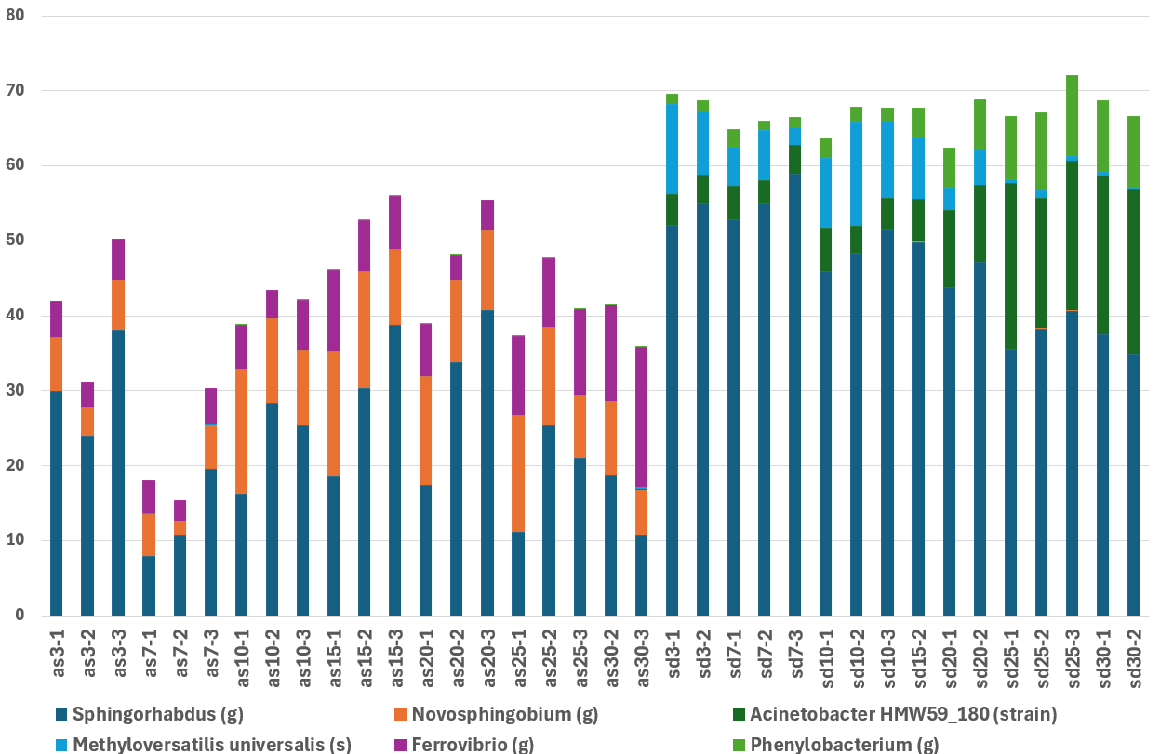
Figure 2: Relative abundances of top 20 most abundant P450s and associated taxa. Taxa were based on BLAST-X search results for unique amplicons. Percent query coverage >97%, percent identity >90%. Letters in parentheses indicate taxa level: g for genus and s for species.

  - FASt analysis of TOrC biodegradation
Twelve individual P450 genes were significantly associated with TOrC degradation in this study, and degraded TOrCs had unique ‘fingerprints’ of associated P450s (Figure 3). These 12 genes originate from a narrow selection of genera, and some (P450_3, 4, and 28) associated with the degradation of multiple TOrCs, while others were uniquely associated with one TOrC. Acetaminophen and ibuprofen, both pain relievers with different modes of action, are notable for having multiple P450s common in their ‘fingerprints’, which may reflect their general structural similarities.
P450s associated with TOrC degradation in this study are highly skewed to Sphingorhabdus and Sphingomonas genera, despite their minimal representation in AS and SD metagenomes. These genera, along with Ferrovibrio, produce sphingoglycolipids, which may be related to their xenobiotic degradation capacity.
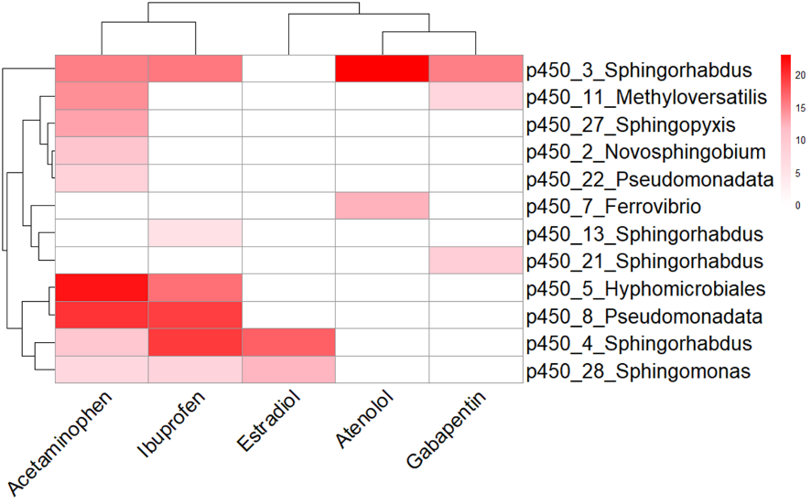
Figure 3. Hierarchically clustered heatmap of P450s significantly correlated with TOrC degradation using Redundancy Analysis (RDA). Color values indicate the strength of the correlation. Maximum p value < 0.02, Heat map units are relative abundance.*****

  - Proteomics
A total of 51 cytochrome P450s were found. Only six were identified with two or more unique peptides and 19 with two or more PSMs. Data completeness was only 18.6% (483 data points out of 2601, for the 51 cytochrome P450 found). The list of unique peptides linked to all identified proteins was used to infer taxonomy composition using Unipept (https://unipept.ugent.be/mpa). Unipept uses the lowest common ancestor as the most specific node in the tree of life that encompasses all taxa associated with the matched peptide(s). Six species of Sphingorhabdus, 17 species of Novosphingobium, two species of Acinetobacter, two species of Methyloversatilis –including Methyloversatilis universalis, one species of Ferrovibrio; and nine species of Phenylobacterium. Matching all of the highly abundant taxa found in our cultures (Figure 2).
Discussion
This study develops and introduces a novel Functional gene Amplicon Sequencing test (FASt) and demonstrates that FASt can uncover functional relationships between microbial genes and contaminant biodegradation in complex environmental microbiomes. To date, microbiome science has placed a high degree of focus on 16S rRNA gene amplicon sequencing because it is a widely available, low-cost tool that can elucidate microbiome structure. However, phylogeny is often not a robust predictor of function, particularly for xenobiotic degradation. Development of FASt was inspired by 16S rRNA gene amplicon sequencing but sought to reimagine this approach by generating amplicons for families of genes associated with biodegradation function, rather than phylogeny alone.
The FASt biomarker development approach is hypothesis-driven and enabled by metagenomic datasets, which are used to design 100s of rhAmp primers. Multi-plex amplicon generation (rhAmp PCR) is combined with amplicon sequencing to screen 100s of genes hypothesized to be involved in a process of interest. FASt can be a low-cost method because 100s of samples can be screened for the cost of amplicon sequencing; after development, cost is expected to be comparable to 16S rRNA gene amplicon sequencing.
Many xenobiotic biodegradation genes, including genes encoding P450 enzymes, monooxygenases, and dioxygenases, belong to complex gene families characterized by a high level of sequence variance. As such, these myriad genes cannot be simultaneously assayed by traditional tools such as quantitative PCR, even if degenerate primers are used. By instead developing a method rooted in amplicon library preparation and subsequent sequencing, hundreds of diverse genes within a family can be simultaneously assayed. Further, by targeting specific gene families, FASt overcomes the limitations of shotgun metagenomics, which often misses rare but functionally critical taxa. In doing so, FASt provided the first evidence, to our knowledge, of suites of P450 genes associated with P450-mediated biodegradation of several trace organic contaminants (TOrCs) by bacterial consortia derived from wastewater.
Additionally, the observation that our microbiomes can degrade ibuprofen via P450-dependent mechanisms represents a novel contribution to this field. Although P450-mediated ibuprofen degradation is known in eukaryotes ^{20,21}, previous studies explicitly testing for bacterial P450 activity reported none. For example, Jia et al.²² observed no inhibition of ibuprofen degradation by the P450 inhibitor 1-ABT in activated sludge. An examination of the microbiome structure reported by Jia et al, and the AS and SD microbiomes shows a lack of overlap in phylogeny. This observation underscores the importance of evaluating microbiomes individually for their functional potential. Known bacterial degraders such as Sphingomonadaceae and more specifically the genus Rhizorhabdus ^{23,24} possess genes for ibuprofen mineralization, but the potentially causative genes found were not P450s. In contrast, our FASt data revealed five P450 genes, mapped to Sphingomonas, Pseudomonas, and Hyphomicrobiales, that were strongly associated with ibuprofen removal. This highlights the value of functional gene–focused methods when enzymatic potential rather than taxonomy is of interest. Standard 16S rRNA gene analyses, which typically resolve only to the genus level, lack the specificity needed to infer such functional differences.
Similarly, FASt detected P450 genes associated with atenolol degradation. The AS microbiome presumably expressed alternate degradation enzymes in the presence of 1-ABT, suggesting metabolic redundancy, while SD reactors lacked this capacity. Literature suggests that atenolol degradation may proceed through O-dealkylation or denitrification^{26,27}, but relevant taxa have not been genetically linked. Here, P450 genes in Sphingorhabdus and Ferrovibrio were associated with atenolol removal, and metabolomics confirmed production of atenolol acid, a hydroxylated metabolite typically formed by P450 activity. The compound was detected only in AS reactors during rapid atenolol loss, strengthening the functional link.
For estradiol, which is commonly degraded by diverse aerobic activated sludge taxa²⁸⁻³⁰, we identified P450 genes associated with its removal, mapping to Sphingorhabdus and Sphingomonas. Prior studies in Rhodococcus and Novosphingobium found P450 involvement downstream of estradiol, specifically acting on estrone^{31,32}. Our finding that 1-ABT delayed estradiol degradation suggests direct or early pathway involvement. The absence of estrone in LC-MS/MS data may indicate complete mineralization or concentrations below the detection limit.
For other TOrCs—gabapentin, diclofenac, gemfibrozil, triclosan, and 5-fluorouracil—biodegradation patterns differed from expectations based on prior work with similar inocula^{8,34,39}. The absence of degradation for gabapentin and gemfibrozil, both previously degraded under similar media conditions, may reflect shifts in community composition or inhibitory effects due to the expanded 12-compound exposure panel, compared to our previous studies, which did not included X, X and X. For triclosan and 5-fluorouracil, degradation occurred without evidence of P450 involvement, consistent with literature attributing these transformations to non-P450 or abiotic processes³⁶⁻³⁸. Lack of intermediate metabolites in LC-MS/MS analyses likely stems from the low TOrC concentrations used and possible full mineralization of degraded compounds. Future work using higher TOrC loads and single-compound reactors could improve detection of intermediate products and validate predicted pathways; however, higher TOrC loads have been shown in some cases to impact microbiome structure and alter results.
Our multi-omics experimental framework was intended to cross-validate FASt results. However, proteomic searches detected 51 P450 proteins out of which only six were highly confident identified (≥2 unique peptides) —mapped to Caulobacter and Bdellovibrio—and none were found to be related to TOrC degradation. This outcome likely reflects the inherent bias of proteomics toward abundant taxa and highly expressed proteins. Additionally, the presence of shared peptide sequences among homologous proteins across organisms limit taxonomic specificity; however, unique peptides may still allow discrimination at the genus or species level. In contrast, FASt captures longer amplicons (~175 bp), offering greater phylogenetic resolution and sensitivity to rare but functionally important genes. Metabolomics provided complementary evidence for enzymatic activity (e.g., atenolol acid formation) but was limited by the complex and overlapping metabolite landscape produced when multiple compounds are degraded together. Other factors that may have affected metabolite detection include compound polarity and low concentration thresholds. However, it should be noted that our data may provide evidence of complete TOrC mineralization, with metabolites decreasing to undetectable levels.
Overall, these comparisons suggest that targeted functional gene sequencing can detect enzymatic potential in low-biomass, complex communities where proteomic and metabolomic methods are unable to do so. Future work should integrate targeted transcriptomics and metabolomics to verify specific gene–function relationships. Additionally, FASt performance should be assessed with a broader range of wastewater-relevant inocula.

Conclusions
This work establishes a proof-of-concept for FASt as a tool for targeted sequencing of functional genes in environmental microbiomes. With this method, it is now possible to screen 100s of known P450 enzyme-encoding genes in each sample, using a single assay. The combination of P450 inhibitor studies and FASt revealed new P450-mediated pathways. By demonstrating higher sensitivity than proteomics, FASt bridges the gap between functional inference and direct genetic evidence. For the select P450-encoding genes associated with biodegradation, targeted biomarker assays (e.g., quantitative PCR assays) can also be developed. As a scalable, cost-effective platform, FASt offers a new approach for identifying predictive biomarkers of microbial function and guiding future mechanistic studies in environmental biotechnology.

Acknowledgements
This work was supported by the National Science Foundation award number 2016396.

We thank Jessica Henley at the Colorado State University Next Generation Sequencing Core for her careful work sequencing our FASt libraries, and Dorathea Lee at the Colorado State University Analytical Resources Core - BIO for their hours of novel computational work. Proteomics and metabolomics data were acquired at the Colorado State University Analytical Resources Core (RRID: SCR_021758). Specifically, proteomics data was acquired using the Orbitrap Eclipse Mass Spectrometer supported by the NSF Grant 2117943.

Data availability
All processed data and analysis files are publicly available at:
Author Contributions Statement
L. N. Janiszewski
N Sachdeva, Neha
E. Schmaljohn, Ellen
J. Chaparro, Jacqueline formal analysis, investigation, writing – review & editing
G. Diaz
J. Topp
N. Downey
C. Broeckling
M. Koslovsky
J. Prenni
S.K. De Long Conceptualization, funding acquisition, supervision, writing – original draft, and writing – review & editing.

Competing interests

Supplementary Table 1. MRM Transitions

Polarity | Name | Component Type | Parent Ion (m/z) | Daughter Ion (m/z) | Retention Time (Min) | CE (V) | EV (V) | CCL2
Negative | 5-fluorouracil-1 | Quantifier | 129 | 42 | 0.65 | 29 | -8 | 44
Negative | 5-fluorouracil-2 | Qualifier | 129 | 86 | 0.65 | 25 | -1 | 48
Positive | Acetominophen-1 | Quantifier | 151.9 | 110 | 2.64 | -21 | 26 | -40
Positive | Acetominophen-2 | Qualifier | 151.9 | 64.9 | 2.64 | -44 | 14 | -52
Positive | Acetominophen-3 | Qualifier | 151.9 | 92.9 | 2.64 | -32 | 25 | -52
Positive | Atenolol-1 | Quantifier | 267 | 145 | 2.94 | -35 | 35 | -96
Positive | Atenolol-2 | Qualifier | 267 | 189.9 | 2.94 | -23 | 36 | -23
Positive | Gabapentin-1 | Quantifier | 172 | 154 | 3.11 | -18 | 0 | -18
Positive | Gabapentin-2 | Qualifier | 172 | 137 | 3.11 | -19 | 25 | -19
Positive | Phenytoin-1 | Quantifier | 252.9 | 181.9 | 6.53 | -27 | 25 | -56
Positive | Phenytoin-2 | Qualifier | 252.9 | 103.9 | 6.53 | -55 | 25 | -52
Positive | Estradiol-1 | Quantifier | 254.9 | 158.9 | 7.74 | -23 | 6 | -76
Positive | Estradiol-2 | Qualifier | 254.9 | 132.9 | 7.74 | -24 | 18 | -76
Positive | Naproxen-1 | Quantifier | 230.9 | 184.9 | 7.78 | -17 | 2 | -72
Positive | Naproxen-2 | Qualifier | 230.9 | 169.9 | 7.78 | -41 | 8 | -112
Positive | Naproxen-3 | Qualifier | 230.9 | 153.1 | 7.78 | -48 | 10 | -60
Positive | Diclofenac-1 | Quantifier | 295.8 | 249.7 | 9.09 | -20 | 13 | -92
Positive | Diclofenac-2 | Qualifier | 295.8 | 214.1 | 9.09 | -60 | 7 | -140
Negative | Diclofenac-d4 | Internal Standard | 299.9 | 256 | 9.07 | 15 | -3 | 60
Positive | Ibuprofen-1 | Quantifier | 206.9 | 161 | 9.23 | -13 | 13 | -44
Positive | Ibuprofen-2 | Qualifier | 206.9 | 104.9 | 9.23 | -31 | 12 | -48
Positive | Ibuprofen-d3 | Internal Standard | 210 | 163.9 | 9.21 | -11 | 0 | -48
Negative | Gemfibrozil-1 | Quantifier | 249 | 121.2 | 9.99 | 17 | -3 | 48
Negative | Gemfibrozil-2 | Qualifier | 249 | 127.2 | 9.99 | 12 | -4 | 52
Negative | Gemfibrozil-d6 | Internal Standard | 255.1 | 121.2 | 9.97 | 15 | -14 | 76
Negative | Triclosan-1 | Quantifier | 286.9 | 35 | 10.55 | 86 | -4 | 96
Negative | Triclosan-2 | Qualifier | 288.9 | 35 | 10.55 | 82 | -10 | 92
Negative | Triclosan-d3 | Internal Standard | 291.9 | 34.9 | 10.53 | 11 | -8 | 52
Positive | Simvastatin-1 | Quantifier | 440.8 | 324.9 | 11.22 | -31 | 24 | -152
Positive | Simvastatin-2 | Qualifier | 440.8 | 294.9 | 11.22 | -47 | 1 | -156
Positive | Simvastatin-3 | Qualifier | 440.8 | 199 | 11.22 | -39 | 45 | -160
Negative | 5-fluorouracil-1 | Quantifier | 129 | 42 | 0.65 | 29 | -8 | 44
Negative | 5-fluorouracil-2 | Qualifier | 129 | 86 | 0.65 | 25 | -1 | 48

References
1. Onesios, K. M., Yu, J. T. & Bouwer, E. J. Biodegradation and removal of pharmaceuticals and personal care products in treatment systems: a review. Biodegradation 20, 441–466 (2009).
2. Onesios-Barry, K. M., Berry, D., Proescher, J. B., Sivakumar, I. K. A. & Bouwer, E. J. Removal of Pharmaceuticals and Personal Care Products during Water Recycling: Microbial Community Structure and Effects of Substrate Concentration. Appl. Environ. Microbiol. 80, 2440–2450 (2014).
3. Pomati, F. et al. Effects of a Complex Mixture of Therapeutic Drugs at Environmental Levels on Human Embryonic Cells. Environ. Sci. Technol. 40, 2442–2447 (2006).
4. Pomati, F., Orlandi, C., Clerici, M., Luciani, F. & Zuccato, E. Effects and Interactions in an Environmentally Relevant Mixture of Pharmaceuticals. Toxicol. Sci. 102, 129–137 (2008).
5. Snyder, S. A., Westerhoff, P., Yoon, Y. & Sedlak, D. L. Pharmaceuticals, Personal Care Products, and Endocrine Disruptors in Water: Implications for the Water Industry. Environ. Eng. Sci. 20, 449–469 (2003).
6. Petre, M. Environmental Biotechnology: New Approaches and Prospective Applications. (BoD – Books on Demand, 2013).
7. Daims, H., Nielsen, J. L., Nielsen, P. H., Schleifer, K.-H. & Wagner, M. In Situ Characterization ofNitrospira-Like Nitrite-Oxidizing Bacteria Active in Wastewater Treatment Plants. Appl. Environ. Microbiol. 67, 5273–5284 (2001).
8. Kim, S. et al. Impact of inoculum sources on biotransformation of pharmaceuticals and personal care products. Water Res. 125, 227–236 (2017).
9. Yoon, M. K., Drewes, J. E. & Amy, G. L. Fate of bulk and trace organics during a simulated aquifer recharge and recovery (ARR)-ozone hybrid process. Chemosphere 93, 2055–2062 (2013).
10. Yu, J. T., Bouwer, E. J. & Coelhan, M. Occurrence and biodegradability studies of selected pharmaceuticals and personal care products in sewage effluent. Agric. Water Manag. 86, 72–80 (2006).
11. de Montellano, P. R. O. 1-Aminobenzotriazole: A Mechanism-Based Cytochrome P450 Inhibitor and Probe of Cytochrome P450 Biology. Med. Chem. 8, 038 (2018).
12. Tsugawa, H. et al. MS-DIAL: data-independent MS/MS deconvolution for comprehensive metabolome analysis. Nat. Methods 12, 523–526 (2015).
13. Nothias, L.-F. et al. Feature-based molecular networking in the GNPS analysis environment. Nat. Methods 17, 905–908 (2020).
14. Jagtap, P. et al. A two-step database search method improves sensitivity in peptide sequence matches for metaproteomics and proteogenomics studies. PROTEOMICS 13, 1352–1357 (2013).
15. Keegan, K. P., Glass, E. M. & Meyer, F. MG-RAST, a Metagenomics Service for Analysis of Microbial Community Structure and Function. in Microbial Environmental Genomics (MEG) (eds Martin, F. & Uroz, S.) 207–233 (Springer, New York, NY, 2016). doi:10.1007/978-1-4939-3369-3_13.
16. Meyer, F. et al. MG-RAST version 4—lessons learned from a decade of low-budget ultra-high-throughput metagenome analysis. Brief. Bioinform. 20, 1151–1159 (2019).
17. Meyer, F. et al. The metagenomics RAST server – a public resource for the automatic phylogenetic and functional analysis of metagenomes. BMC Bioinformatics 9, 386 (2008).
18. Callahan, B. J. et al. DADA2: High-resolution sample inference from Illumina amplicon data. Nat. Methods 13, 581–583 (2016).
19. Bolyen, E. et al. Reproducible, interactive, scalable and extensible microbiome data science using QIIME 2. Nat. Biotechnol. 37, 852–857 (2019).
20. He, Y. et al. Metabolism of Ibuprofen by Phragmites australis: Uptake and Phytodegradation. Environ. Sci. Technol. 51, 4576–4584 (2017).
21. Rinnofner, C., Kerschbaumer, B., Weber, H., Glieder, A. & Winkler, M. Cytochrome P450 mediated hydroxylation of ibuprofen using Pichia pastoris as biocatalyst. Biocatal. Agric. Biotechnol. 17, 525–528 (2019).
22. Jia, Y. et al. Biotransformation of ibuprofen in biological sludge systems: Investigation of performance and mechanisms. Water Res. 170, 115303 (2020).
23. Wittich, R.-M., Haïdour, A., Aguilar-Romero, I., de la Torre-Zúñiga, J. & van Dillewijn, P. Biodegradation of Microtoxic Phenylpropanoids (Phenylpropanoic Acid and Ibuprofen) by Bacteria and the Relevance for Their Removal from Wastewater Treatment Plants. Genes 14, 442 (2023).
24. Chen, R., Huang, J., Li, X., Yang, C. & Wu, X. Functional characterization of an efficient ibuprofen-mineralizing bacterial consortium. J. Hazard. Mater. 447, 130751 (2023).
25. Aguilar-Romero, I. et al. Effluent decontamination by the ibuprofen-mineralizing strain, Sphingopyxis granuli RW412: Metabolic processes. Environ. Pollut. 274, 116536 (2021).
26. Xu, Y., Radjenovic, J., Yuan, Z. & Ni, B.-J. Biodegradation of atenolol by an enriched nitrifying sludge: Products and pathways. Chem. Eng. J. 312, 351–359 (2017).
27. Yi, M. et al. Mechanism of β-blocker biodegradation by wastewater microorganisms. J. Hazard. Mater. 444, 130338 (2023).
28. Castellanos, R. M., Bassin, J. P., Bila, D. M. & Dezotti, M. Biodegradation of natural and synthetic endocrine-disrupting chemicals by aerobic granular sludge reactor: Evaluating estrogenic activity and estrogens fate. Environ. Pollut. 274, 116551 (2021).
29. Yu, C.-P., Deeb, R. A. & Chu, K.-H. Microbial degradation of steroidal estrogens. Chemosphere 91, 1225–1235 (2013).
30. Haiyan, R., Shulan, J., ud din Ahmad, N., Dao, W. & Chengwu, C. Degradation characteristics and metabolic pathway of 17α-ethynylestradiol by Sphingobacterium sp. JCR5. Chemosphere 66, 340–346 (2007).
31. Ibero, J., Galán, B., Rivero-Buceta, V. & García, J. L. Unraveling the 17β-Estradiol Degradation Pathway in Novosphingobium tardaugens NBRC 16725. Front. Microbiol. 11, (2020).
32. Li, S. et al. Identification of novel catabolic genes involved in 17β-estradiol degradation by Novosphingobium sp. ES2-1. Environ. Microbiol. 23, 2550–2563 (2021).
33. Wu, X. et al. Biodegradation pathways and mechanisms of 17α-ethynylestradiol via functional enzymes in the freshwater microalga Scenedesmus quadricauda. Water Res. 281, 123569 (2025).
34. Onesios, K. M. & Bouwer, E. J. Biological removal of pharmaceuticals and personal care products during laboratory soil aquifer treatment simulation with different primary substrate concentrations. Water Res. 46, 2365–2375 (2012).
35. Henning, N., Wick, A. & Ternes, T. A. Biotransformation of pregabalin in surface water matrices and the occurrence of transformation products in the aquatic environment - comparison to the structurally related gabapentin. Water Res. 203, 117488 (2021).
36. Weitekamp, C. A. et al. Triclosan-Selected Host-Associated Microbiota Perform Xenobiotic Biotransformations in Larval Zebrafish. Toxicol. Sci. 172, 109–122 (2019).
37. Guo, F. et al. Computational Biotransformation Profile of Emerging Phenolic Pollutants by Cytochromes P450: Phenol-Coupling Mechanism. Environ. Sci. Technol. 54, 2902–2912 (2020).
38. Ljoncheva, M., Kosjek, T., Isidori, M. & Heath, E. 5-Fluorouracil and Its Prodrug Capecitabine: Occurrence, Fate and Effects in the Environment. in Fate and Effects of Anticancer Drugs in the Environment (eds Heath, E., Isidori, M., Kosjek, T. & Filipič, M.) 331–375 (Springer International Publishing, Cham, 2020). doi:10.1007/978-3-030-21048-9_14.
39. Rossmassler, K. et al. Impact of primary carbon sources on microbiome shaping and biotransformation of pharmaceuticals and personal care products. Biodegradation 30, 127–145 (2019).
40. Prior, J. E., Shokati, T., Christians, U. & Gill, R. T. Identification and characterization of a bacterial cytochrome P450 for the metabolism of diclofenac. Appl. Microbiol. Biotechnol. 85, 625–633 (2010).
41. Kjeldal, H. et al. Genomic, Proteomic, and Metabolite Characterization of Gemfibrozil-Degrading Organism Bacillus sp. GeD10. Environ. Sci. Technol. 50, 744–755 (2016).
42. Ottmar, K. J., Colosi, L. M. & Smith, J. A. Sorption of Statin Pharmaceuticals to Wastewater-Treatment Biosolids, Terrestrial Soils, and Freshwater Sediment. J. Environ. Eng. 136, 256–264 (2010).

